**2022.9.3高三三校联考续写(初稿）**

阅读下面材料，根据其内容和所给段落开头语续写两段，使之构成一篇完整的短文。学科网 zxxk.com

**Our Garden and the Salad**

“Christine, come and help me in the garden. I want to plant all of the seeds today.” My father was calling to me. “I’m busy...” I said. I didn’t understand why working in the dirt excited him so much.

By the end of April, his plants had come up in neat rows. Unfortunately, in early May, my father was seriously injured in an accident. He was in hospital for about two months and during that time he often asked me about his garden. Even after he came home, he had to stay in bed for a while.

My mother had several business trips so I said that I would take care of his garden. I assumed that the little plants would continue to grow as long as they had water, and luckily it rained fairly often so I didn’t think much about the garden.

One Saturday morning in July, my father said to me, “Christine, I think that the vegetables should be about ready to be picked. Let’s have a salad today!” I took a bowl and went out to the garden. I looked at the leaves and was upset to see that many of the leaves had been half eaten. There were hundreds of bugs(虫子) all over them! I tried to get them off, but there were just too many. I looked at the carrots next, but they didn’t look healthy.

I got in panic for a moment, but then thought of a good idea. I quietly went to the nearest store to buy some vegetables. I went back home and cut them up to make a salad for my father. When I gave it to him, he said, “Oh, Christine, what a beautiful salad! You must be taking very good care of my garden.” My father looked happy, but I felt a little bit guilty.

注意:

1. 续写词数应为150左右；
2. 请按如下格式在答题卡的相应位置作答。

|  |
| --- |
| I went back to the kitchen when my mother came home.  I carefully made a salad and took it to my father. |

**作者：Kelly 梁向群 审稿：Brittany何海艳**

**Version 1**

I went back to the kitchen when my mother came home. She sensed something wrong from my embarrassed look and asked what had happened. I fumbled helplessly for words to explain my white lie. Mother couldn’t help laughing, saying Father was such a green thumb that he must have seen through my trick simply by a glance at the salad. If only I had really taken good care of Father’s, or rather, OUR garden! With Mum’s company, I gathered my courage to apologize to Dad, who returned a forgiving and understanding smile and taught me some tricks to rid the vegetables of bugs. I promised Dad to make him a salad with our own organic vegetables. Whether sunny, windy or rainy, the next few weeks witnessed my toil and sweat in the garden, vegetables taking on a healthy new look. Overwhelmed with excitement, I harvested a big basket of them. (139)

I carefully made a salad and took it to my father. “Amazing!” With stars in his eyes, he savored the salad as if it were the the world first-class cuisine. “It’s your honesty, responsibility, care and love that made it unparalleled!”I looked him in the eye and knew for sure he truly meant every single word. Last time I thought I was a good actress, but Father turned out to be a better actor; this time neither of us needed to pretend. Our vegetables had just gone through a severe injury like Dad. It wasn’t long before Father recovered and continued his daily garden work, with me to help here and there. I finally understand why working in the dirt excited him so much. No autumn harvest without spring work. -----The simple yet profound lesson learned from my beloved father and our garden has guided me through all these years. (139)

**Version 2**

I went back to the kitchen when my mother came home. She sensed something wrong from my embarrassment. With my eyes fixed on the floor, I told her everything tongue-tied. Mother couldn’t help laughing, saying Father was such a green thumb that he must have seen through my trick simply by a look at the salad. How I wish I had really taken good care of the garden! With Mum’s company, I gathered my courage to apologize to Dad, who returned a forgiving and understanding smile and taught me some tricks to rid the vegetables of bugs. Under Dad’s guidance, for the next few weeks, I soaked myself in the lovely garden. There was a time when excitement engulfed me as buds shot. Finally, it was time to harvest the organic food, ingredients of my homemade feast. (128)

I carefully made a salad and took it to my father. “Amazing!” Eyes sparkling, he raised his thumb up while chewing the salad made of the newly-picked vegetables. “It’s your honesty, responsibility, care and love that made it unparalleled!” I looked him in the eye and knew for sure he truly meant every single word. A sense of pride surged through my body. It wasn’t long before Father recovered and continued his daily garden work, with me to help here and there. Now I understand why working in the dirt excited him so much. When life begins to move in the soil after seeds of hope were spread, a sense of achievement welled up inside my body. Our lovely garden has witnessed my growth. (113)

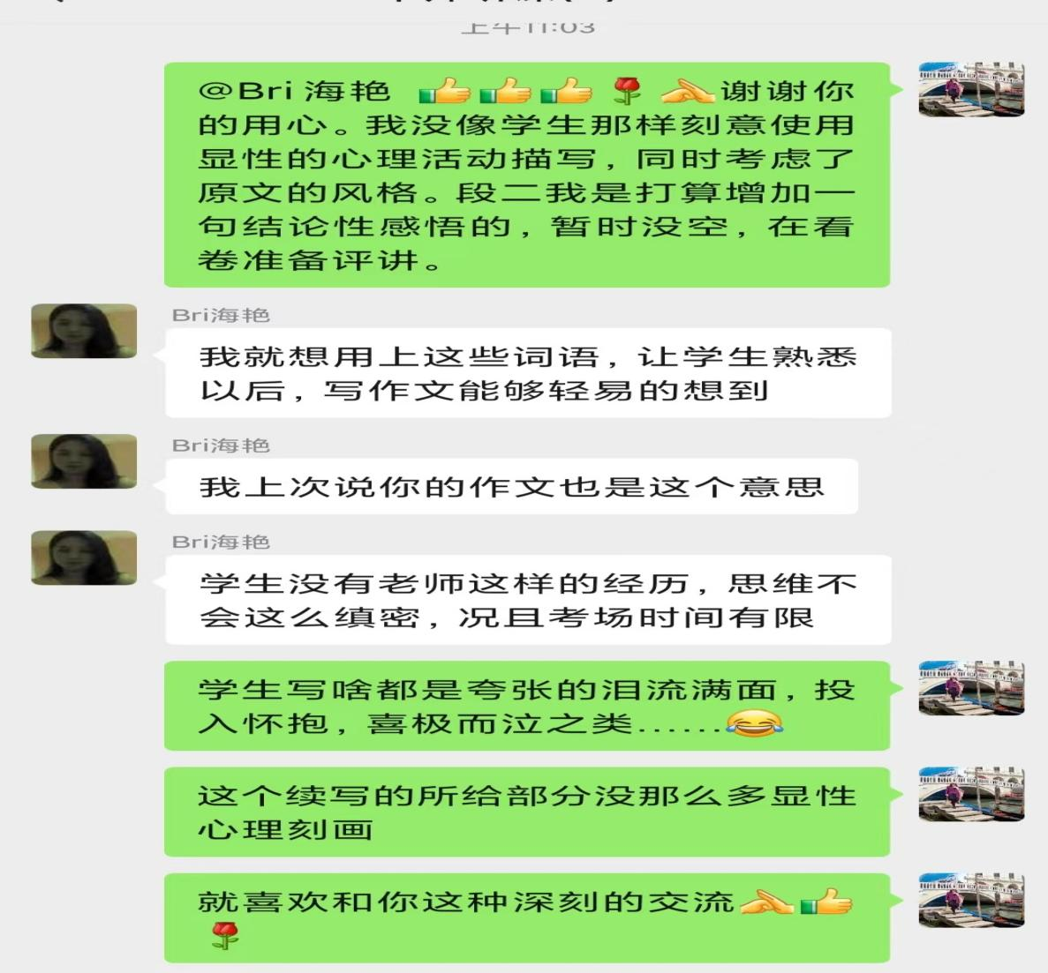

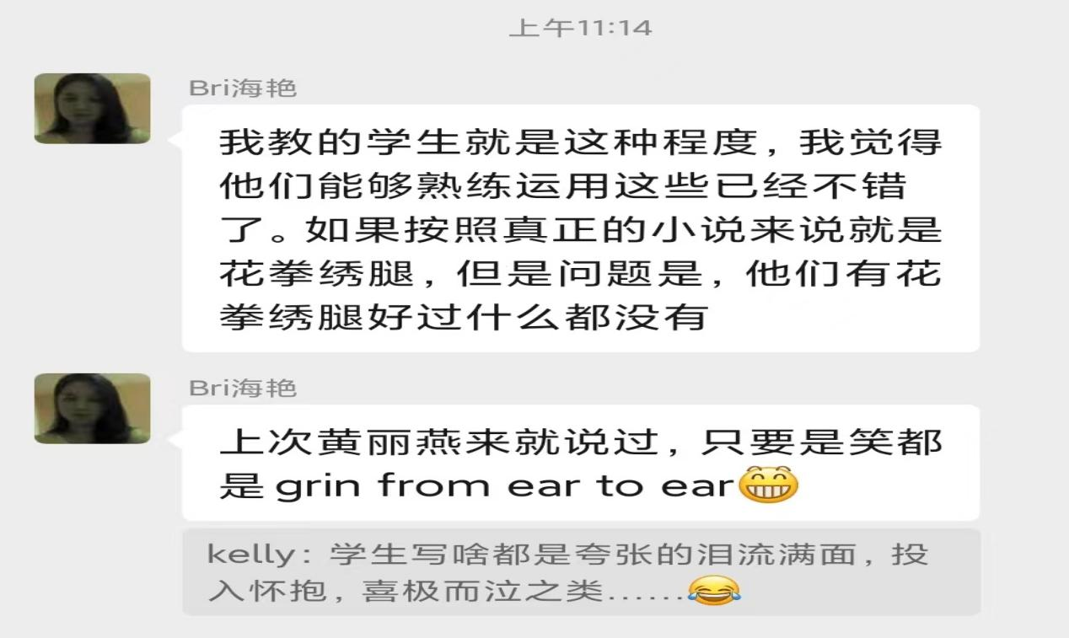

**分享和海艳老师的部分交流内容如上。Version 2 里的一些心理活动刻画是海艳老师写的。Open question:这类描写是否会长在阅卷老师的审美点上？同学们平时背诵的语料该怎样活用？如何理解续写要沿袭原文表达风格的说法？欢迎发表看法和批评指正。**